AIM: Simulate cross correlation and autocorrelation on discrete time signals.

Theory:

Cross-correlation and autocorrelation are mathematical operations used to measure the similarity or relationship between signals. They are important techniques in Digital Signal Processing (DSP) and are also widely used in applications such as signal processing, image processing, communication systems, and pattern recognition.

Cross-correlation measures the similarity between two different signals at different time shifts or time lags. It is calculated by comparing one signal with a time-shifted version of the other signal, generally using the dot product of their overlapping samples. The resulting cross-correlation signal shows how strongly the two signals are related at each possible time lag. A higher correlation value indicates greater similarity between the signals at that particular shift.

Autocorrelation, on the other hand, measures the similarity of a signal with itself at different time shifts. It can be considered as the cross-correlation of a signal with itself. The resulting autocorrelation signal indicates how closely the signal matches its delayed versions. It is particularly useful for identifying repeating patterns, periodicity, and other characteristics within a signal.

Thus, cross-correlation is mainly used to determine the relationship or time delay between two signals, while autocorrelation is used to study the internal similarity and periodic behavior of a single signal.

Flowchart:
The flowchart for the program will consist of the following steps:
Define two discrete-time signals (signal 1 and signal 2) or use the same signal for autocorrelation.
Compute the cross-correlation of the two signals or the autocorrelation of a single signal. Plot and display the cross-correlation or autocorrelation signal.
Save the cross-correlation or autocorrelation signal (optional).
Now, let's see the Python program that simulates cross-correlation and autocorrelation on discrete-time signals:

Program:
import numpy as np

import matplotlib.pyplot as plt
def cross_correlation(signal1, signal2):
# Compute the cross-correlation
cross_corr = np.correlate(signal1, signal2, mode='full') return cross_corr
def autocorrelation(signal):
# Compute the autocorrelation
auto_corr = np.correlate(signal, signal, mode='full') return auto_corr
# Define the discrete-time signals signal1 = np.array([1, 2, 3, 4, 5])
signal2 = np.array([2, 4, 6, 8, 10]) # Compute the cross-correlation
cross_corr = cross_correlation(signal1, signal2) # Compute the autocorrelation
auto_corr = autocorrelation(signal1)
# Plot the cross-correlation and autocorrelation signals plt.figure(figsize=(10, 6))
plt.subplot(2, 1, 1) plt.stem(cross_corr) plt.title('Cross-correlation') plt.xlabel('Time Lag') plt.ylabel('Magnitude') plt.subplot(2, 1, 2) plt.stem(auto_corr) plt.title('Autocorrelation') plt.xlabel('Time Lag') plt.ylabel('Magnitude') plt.tight_layout() plt.show()
# Save the cross-correlation or autocorrelation signals (optional) # np.savetxt('cross_correlation.txt', cross_corr, delimiter=',')
# np.savetxt('autocorrelation.txt', auto_corr, delimiter=',')

Explanation
This program calculates and displays the cross-correlation between two discrete-time signals and the autocorrelation of one signal. It uses NumPy for the correlation calculations and Matplotlib for visualizing the results.
Step 1: Import Required Libraries
import numpy as np
import matplotlib.pyplot as plt
The program imports two libraries.
- NumPy is used for creating arrays and performing correlation calculations.
- Matplotlib is used to plot and display the cross-correlation and autocorrelation results.
Step 2: Define the Cross-Correlation Function
def cross_correlation(signal1, signal2):

# Compute the cross-correlation
cross_corr = np.correlate(signal1, signal2, mode='full')
return cross_corr
This function calculates the cross-correlation between two different signals.
The np.correlate() function compares signal1 with different shifted positions of signal2.
The parameter:
mode='full'
calculates the correlation for all possible time lags between the two signals.
The calculated result is stored in cross_corr and returned by the function.
Step 3: Define the Autocorrelation Function
def autocorrelation(signal):

# Compute the autocorrelation
auto_corr = np.correlate(signal, signal, mode='full')
return auto_corr
This function calculates the autocorrelation of a signal.
Here, the same signal is passed twice to np.correlate():
np.correlate(signal, signal, mode='full')
Therefore, the signal is compared with its own time-shifted versions.
The calculated result is stored in auto_corr and returned by the function.
Step 4: Define the Discrete-Time Signals
signal1 = np.array([1, 2, 3, 4, 5])
signal2 = np.array([2, 4, 6, 8, 10])
Two discrete-time signals are defined using NumPy arrays.
Here:
signal1 = [1, 2, 3, 4, 5]
signal2 = [2, 4, 6, 8, 10]
signal2 is exactly two times signal1, so the two signals have a strong relationship.
Step 5: Calculate Cross-Correlation
cross_corr = cross_correlation(signal1, signal2)
The cross_correlation() function is called using signal1 and signal2.
The function compares the two signals at different time lags and produces the corresponding correlation values.
The result is stored in:
cross_corr
These values indicate the similarity between the two signals at different shifts.
Step 6: Calculate Autocorrelation
auto_corr = autocorrelation(signal1)
The autocorrelation() function is called using signal1.
The function compares signal1 with its own shifted versions.
The resulting values are stored in:
auto_corr
The largest value generally occurs at zero time lag, where the signal is compared directly with itself.
Step 7: Create the Figure
plt.figure(figsize=(10, 6))
A figure is created with a width of 10 inches and a height of 6 inches.
This figure will contain two separate plots:
- Cross-correlation
- Autocorrelation
Step 8: Plot the Cross-Correlation
plt.subplot(2, 1, 1)
plt.stem(cross_corr)
plt.title('Cross-correlation')
plt.xlabel('Time Lag')
plt.ylabel('Magnitude')
The first subplot is created using:
plt.subplot(2, 1, 1)
This means the figure is divided into 2 rows and 1 column, and this is the first plot.
plt.stem() displays the cross-correlation values as a discrete-time signal.
The x-axis represents Time Lag, while the y-axis represents the Magnitude of correlation.
Step 9: Plot the Autocorrelation
plt.subplot(2, 1, 2)
plt.stem(auto_corr)
plt.title('Autocorrelation')
plt.xlabel('Time Lag')
plt.ylabel('Magnitude')
The second subplot is created using:
plt.subplot(2, 1, 2)
This displays the autocorrelation result below the cross-correlation plot.
The stem plot shows how the similarity of signal1 changes when the signal is shifted by different time lags.
Step 10: Adjust and Display the Plots
plt.tight_layout()
plt.show()
plt.tight_layout() automatically adjusts the spacing between the two plots so that the labels and titles do not overlap.
Finally:
plt.show()
displays both correlation plots.
Step 11: Save the Results (Optional)
# np.savetxt('cross_correlation.txt', cross_corr, delimiter=',')
# np.savetxt('autocorrelation.txt', auto_corr, delimiter=',')
These lines can optionally be used to save the calculated correlation results into text files.
The first line saves the cross-correlation values:
cross_correlation.txt
The second line saves the autocorrelation values:
autocorrelation.txt
The lines are currently commented using #, so they will not execute unless the comments are removed.
Overall Working
The program first defines two discrete-time signals and creates separate functions for cross-correlation and autocorrelation. Cross-correlation compares the two different signals at various time lags, while autocorrelation compares signal1 with its own delayed versions. The calculated results are then displayed using stem plots, allowing the relationship between the signals and their time-lag behavior to be easily observed. The results can also optionally be saved to text files for further analysis.

Expected Output
A figure will be displayed containing four stem plots:
- Signal 1 – displays the samples [1, 2, 3, 4, 5].
- Signal 2 – displays the samples [2, 4, 6, 8, 10].
- Cross-Correlation – shows the correlation between Signal 1 and Signal 2 at different time lags.
- Autocorrelation – shows the correlation of Signal 1 with its delayed versions, with the maximum value occurring at zero lag.
The plots provide a visual comparison of the original signals and their correlation characteristics.

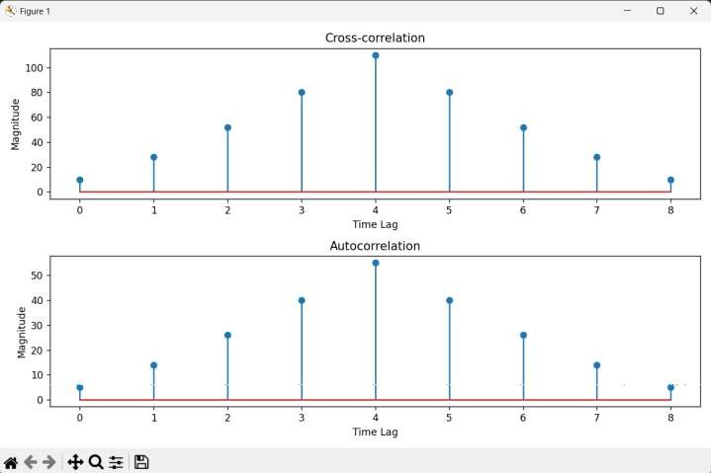

Flowchart
- • Start the program.
- • Define two discrete-time signals (signal1 and signal2) for cross-correlation, or use the same signal for autocorrelation.
- • Compute the cross-correlation between the two signals or compute the autocorrelation of a single signal.
- • Store the calculated correlation values in the respective output arrays.
- • Plot and display the cross-correlation or autocorrelation results using a stem plot.
- • Save the correlation results to a file if required (optional).
- • End the program.

Theory
What is Correlation?
Correlation is a mathematical operation used to measure the similarity or relationship between two signals, functions, or waveforms. It helps determine how closely two signals are related to each other when they are compared at different time positions.
Correlation is widely used in Digital Signal Processing (DSP) and other fields such as image processing, communication systems, pattern recognition, radar, and sonar.
There are two main types of correlation:
- Cross-correlation
- Autocorrelation
Cross-Correlation
Cross-correlation is used to measure the similarity between two different signals. It compares one signal with a time-delayed or shifted version of another signal.
The signals are shifted relative to each other, and at every time shift, their corresponding samples are compared. The resulting correlation value indicates the degree of similarity or relatedness between the two signals at that particular time lag.
If the correlation value is high, the two signals are more similar at that particular time shift. If the value is low, the signals have less similarity.
Cross-correlation is especially useful when a desired signal is mixed with an unwanted signal or noise. By comparing the received signal with a known reference signal, cross-correlation can help detect the desired signal and determine its time delay.
Applications of cross-correlation include:
- Signal detection
- Time-delay estimation
- Noise and signal analysis
- Pattern matching
- Radar and sonar systems
- Communication systems
Autocorrelation
Autocorrelation measures the similarity between a signal and its own time-delayed version. In other words, it is the correlation of a signal with itself.
The signal is shifted by different time lags and compared with its original form. The resulting autocorrelation values indicate how similar the signal is to itself at each time shift.
Autocorrelation is particularly useful for identifying repeating patterns, periodicity, and signal characteristics. The maximum correlation generally occurs at zero time lag, because the signal is being compared directly with itself.
Autocorrelation is commonly used in:
- Radar systems
- Sonar systems
- Satellite communication
- Wireless communication
- Periodicity detection
- Signal analysis
- Power and energy analysis
Cross-Correlation | Autocorrelation
Compares two different signals. | Compares a signal with itself.
Measures similarity between two signals at different time lags. | Measures similarity between a signal and its delayed versions.
Useful for finding relationships and time delays. | Useful for finding periodicity and internal signal characteristics.
Commonly used for signal detection. | Commonly used for periodicity and signal analysis.

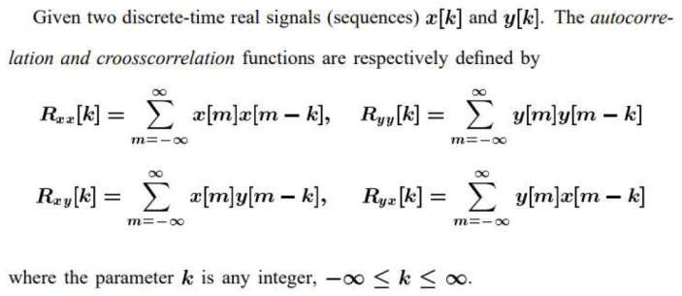

Flowchart/Steps:

- The flowchart for the program will consist of the following steps:
- Define two discrete-time signals (signal 1 and signal 2) or use the same signal for autocorrelation.
- Compute the cross-correlation of the two signals or the autocorrelation of a single signal.
- Plot and display the cross-correlation or autocorrelation signal.
- Save the cross-correlation or autocorrelation signal (optional).

Code 2:
import numpy as np
import matplotlib.pyplot as plt
def cross_correlation(signal1, signal2):
# Compute the cross-correlation
cross_corr = np.correlate(signal1, signal2, mode='full') return cross_corr
def autocorrelation(signal):
# Compute the autocorrelation
auto_corr = np.correlate(signal, signal, mode='full') return auto_corr
# Define the discrete-time signals

signal1 = np.array([1, 2, 3, 4, 5])
signal2 = np.array([2, 4, 6, 8, 10]) # Compute the cross-correlation
cross_corr = cross_correlation(signal1, signal2) # Compute the autocorrelation
auto_corr = autocorrelation(signal1)
# Plot the cross-correlation and autocorrelation signals plt.figure(figsize=(10, 6))
# Signal 1
plt.subplot(4, 1, 1) plt.stem(signal1) plt.title('signal1') plt.xlabel('Time Lag') plt.ylabel('Magnitude') # Signal 2
plt.subplot(4, 1, 2) plt.stem(signal2) plt.title('signal2') plt.xlabel('Time Lag') plt.ylabel('Magnitude') # Cross-correlation plt.subplot(4, 1, 3) plt.stem(cross_corr)
plt.title('Cross-correlation') plt.xlabel('Time Lag') plt.ylabel('Magnitude')
# Autocorrelation plt.subplot(4, 1, 4) plt.stem(auto_corr) plt.title('Autocorrelation') plt.xlabel('Time Lag') plt.ylabel('Magnitude') plt.tight_layout() plt.show()

Explanation
This program calculates the cross-correlation between two discrete-time signals and the autocorrelation of the first signal. It also displays the original signals along with their correlation results in four separate plots.
Step 1: Import Required Libraries
import numpy as np
import matplotlib.pyplot as plt
Two Python libraries are imported.
- NumPy is used to create discrete-time signals and perform correlation calculations.
- Matplotlib is used to visualize the signals and correlation results.

Step 2: Define the Cross-Correlation Function
def cross_correlation(signal1, signal2):

# Compute the cross-correlation
cross_corr = np.correlate(signal1, signal2, mode='full')
return cross_corr
This function calculates the cross-correlation between signal1 and signal2.
The function uses:
np.correlate(signal1, signal2, mode='full')
The mode='full' parameter calculates the correlation for all possible time lags between the two signals.
The calculated result is stored in cross_corr and then returned.

Step 3: Define the Autocorrelation Function
def autocorrelation(signal):

# Compute the autocorrelation
auto_corr = np.correlate(signal, signal, mode='full')
return auto_corr
This function calculates the autocorrelation of a signal.
The same signal is given twice to np.correlate():
np.correlate(signal, signal, mode='full')
Therefore, the signal is compared with its own time-shifted versions.
The calculated result is stored in auto_corr and returned.

Step 4: Define the Discrete-Time Signals
signal1 = np.array([1, 2, 3, 4, 5])
signal2 = np.array([2, 4, 6, 8, 10])
Two discrete-time signals are created using NumPy.
The signals are:
Signal 1 = [1, 2, 3, 4, 5]
Signal 2 = [2, 4, 6, 8, 10]
Here, signal2 is twice signal1, so there is a strong relationship between the two signals.

Step 5: Calculate Cross-Correlation
cross_corr = cross_correlation(signal1, signal2)
The cross_correlation() function is called using both signals.
It compares signal1 and signal2 at different time lags and calculates their similarity.
The result is stored in:
cross_corr
This result will be displayed later in the third subplot.

Step 6: Calculate Autocorrelation
auto_corr = autocorrelation(signal1)
The autocorrelation() function is called using signal1.
It compares signal1 with its own delayed versions at different time lags.
The result is stored in:
auto_corr
This result will be displayed in the fourth subplot.

Step 7: Create the Figure
plt.figure(figsize=(10, 8))
A figure with a width of 10 inches and a height of 8 inches is created.
The figure will contain four separate plots:
- Signal 1
- Signal 2
- Cross-correlation
- Autocorrelation

Step 8: Plot Signal 1
plt.subplot(4, 1, 1)
plt.stem(signal1)
plt.title('Signal 1')
plt.xlabel('Time Lag')
plt.ylabel('Magnitude')
The first subplot displays signal1.
plt.subplot(4, 1, 1)
means that the figure is divided into 4 rows and 1 column, and this is the first plot.
plt.stem() is used because the signal contains discrete-time samples.

Step 9: Plot Signal 2
plt.subplot(4, 1, 2)
plt.stem(signal2)
plt.title('Signal 2')
plt.xlabel('Time Lag')
plt.ylabel('Magnitude')
The second subplot displays signal2.
It shows the individual samples of the second discrete-time signal.

Step 10: Plot Cross-Correlation
plt.subplot(4, 1, 3)
plt.stem(cross_corr)
plt.title('Cross-correlation')
plt.xlabel('Time Lag')
plt.ylabel('Magnitude')
The third subplot displays the calculated cross-correlation.
It shows how the similarity between signal1 and signal2 changes at different time lags.
A larger magnitude indicates stronger similarity between the two signals at that particular lag.

Step 11: Plot Autocorrelation
plt.subplot(4, 1, 4)
plt.stem(auto_corr)
plt.title('Autocorrelation')
plt.xlabel('Time Lag')
plt.ylabel('Magnitude')
The fourth subplot displays the autocorrelation of signal1.
It shows how similar signal1 is to its own shifted versions.
The highest value occurs at zero lag, because the signal is being compared directly with itself.

Step 12: Adjust and Display the Plots
plt.tight_layout()
plt.show()
plt.tight_layout() automatically adjusts the spacing between the four plots so that the titles and labels do not overlap.
Finally:
plt.show()
displays all four plots together.

Overall Working
The program first creates two discrete-time signals. It then calculates the cross-correlation between the two signals and the autocorrelation of signal1. Finally, it displays the two original signals and their corresponding correlation results using four separate stem plots.

Expected Output
A figure will be displayed containing four stem plots:
- Signal 1 – displays the samples [1, 2, 3, 4, 5].
- Signal 2 – displays the samples [2, 4, 6, 8, 10].
- Cross-Correlation – shows the correlation between Signal 1 and Signal 2 at different time lags.
- Autocorrelation – shows the correlation of Signal 1 with its delayed versions, with the maximum value occurring at zero lag.
The plots provide a visual comparison of the original signals and their correlation characteristics.

OUTPUT:
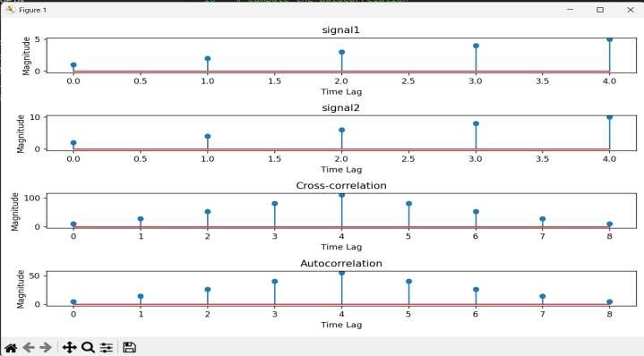

Observation

In this experiment, two discrete-time signals, Signal 1 and Signal 2, were defined and analyzed using cross-correlation and autocorrelation. The cross-correlation results showed a strong relationship between the two signals because Signal 2 is directly proportional to Signal 1. The correlation values were highest when the signals were properly aligned and decreased as the time lag increased. This indicates that the similarity between the two signals changes according to their relative time shift.

The autocorrelation of Signal 1 showed the highest value at zero time lag, because the signal is compared directly with itself at this point. The autocorrelation graph was symmetric around the center, which is a characteristic of autocorrelation for real-valued signals. As the time lag increased in either direction, the overlapping samples decreased, causing the correlation magnitude to decrease. The stem plots clearly showed the relationship between the original signals and their correlation characteristics.

Conclusion

From this experiment, I gained a clear understanding of how cross-correlation and autocorrelation are used to analyze discrete-time signals. Cross-correlation was used to measure the similarity between two different signals at different time lags, while autocorrelation was used to determine how similar a signal is to its own time-shifted versions. Since Signal 2 is directly related to Signal 1, the cross-correlation produced relatively high values, confirming the strong relationship between the two signals. The autocorrelation of Signal 1 produced its maximum value at zero lag, which indicates that the signal has its highest similarity with itself when there is no time shift. The decrease in correlation values as the lag increased showed that the similarity between the overlapping portions of the signals also decreases. The symmetric nature of the autocorrelation result further demonstrates an important characteristic of real-valued signals. Overall, this experiment provided practical knowledge of correlation techniques and showed their importance in signal comparison, signal detection, time-delay estimation, pattern recognition, periodicity analysis, and communication systems.

Github:-
https://github.com/manav-chotai081/DSIP/tree/main/Experiment%203

